**‘I am the gate for the sheep.’**

**Reading:** John 10:7-10

Jesus said, “What I’m about to tell you is true. I am like a gate for the sheep. All who have come before me are thieves and robbers. But the sheep have not listened to them. I’m like a gate. Anyone who enters through me will be saved. They will come in and go out. And they will find plenty of food. A thief comes only to steal and kill and destroy. I have come so they may have life. I want them to have it in the fullest possible way.

**Thought about the reading**

When Jesus was alive, the sheep would go out in the fields during the day. The shepherd would lead them, and they would follow him to the best grass, and to clean water. At nighttime, the shepherd would lead them to the sheepfold. This was a field with a wall around it and a gate. The shepherd would open the gate to let the sheep in. Then he would shut the gate to keep out thieves and robbers and wild animals. This kept the sheep safe.

Sometimes, if there was no gate, the shepherd would lie in the gateway instead. He himself would become the gate to keep the sheep safe.

Jesus said that those that follow him are like sheep. He is the shepherd who lies in the gateway. He keeps us safe. He is the way into the safe place. If we listen to him and trust him, he will care for us and keep us safe.

**Prayer**

Lord Jesus, thank you that you are like a gate. Thank you that you keep us safe, just like the gate keeps the sheep safe at night.

Lord Jesus, please help me to follow you and trust you.

Amen

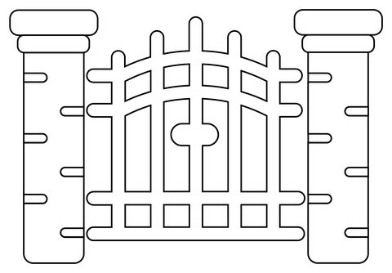

**Jesus is the gate for the sheep**

**Cambridge Causeway**

Autumn 2023

Bible Study notes

**Jesus said ‘I am…’**

**3. I am the gate for the sheep**

By Chrissy Cole